Place Your Title Here in Times New Roman Font Size 14 Bold

Presenting Author,¹ Additional Author,¹ and Additional Author²
¹Department, University or Research Institute, City, State, Country
²Department, University or Research Institute, City, State, Country

Place text here in Times New Roman Font 12. The abstract, including any figure and references, must not exceed one page. The submitted abstract should follow the formatting provided in this template. All fonts are Times New Roman. The font sizes are as follows: Title (14, bold), Presenting Author (13, underlined), Additional Authors (13), Department or Institute Affiliation (12, Italicized), Abstract Text (12), Figure Caption (10), References (11). Submitted abstracts should be saved in the .doc or .docx format and titled with the author last name first (Example: Smith_Joe_TeraNano_Abstract.doc).

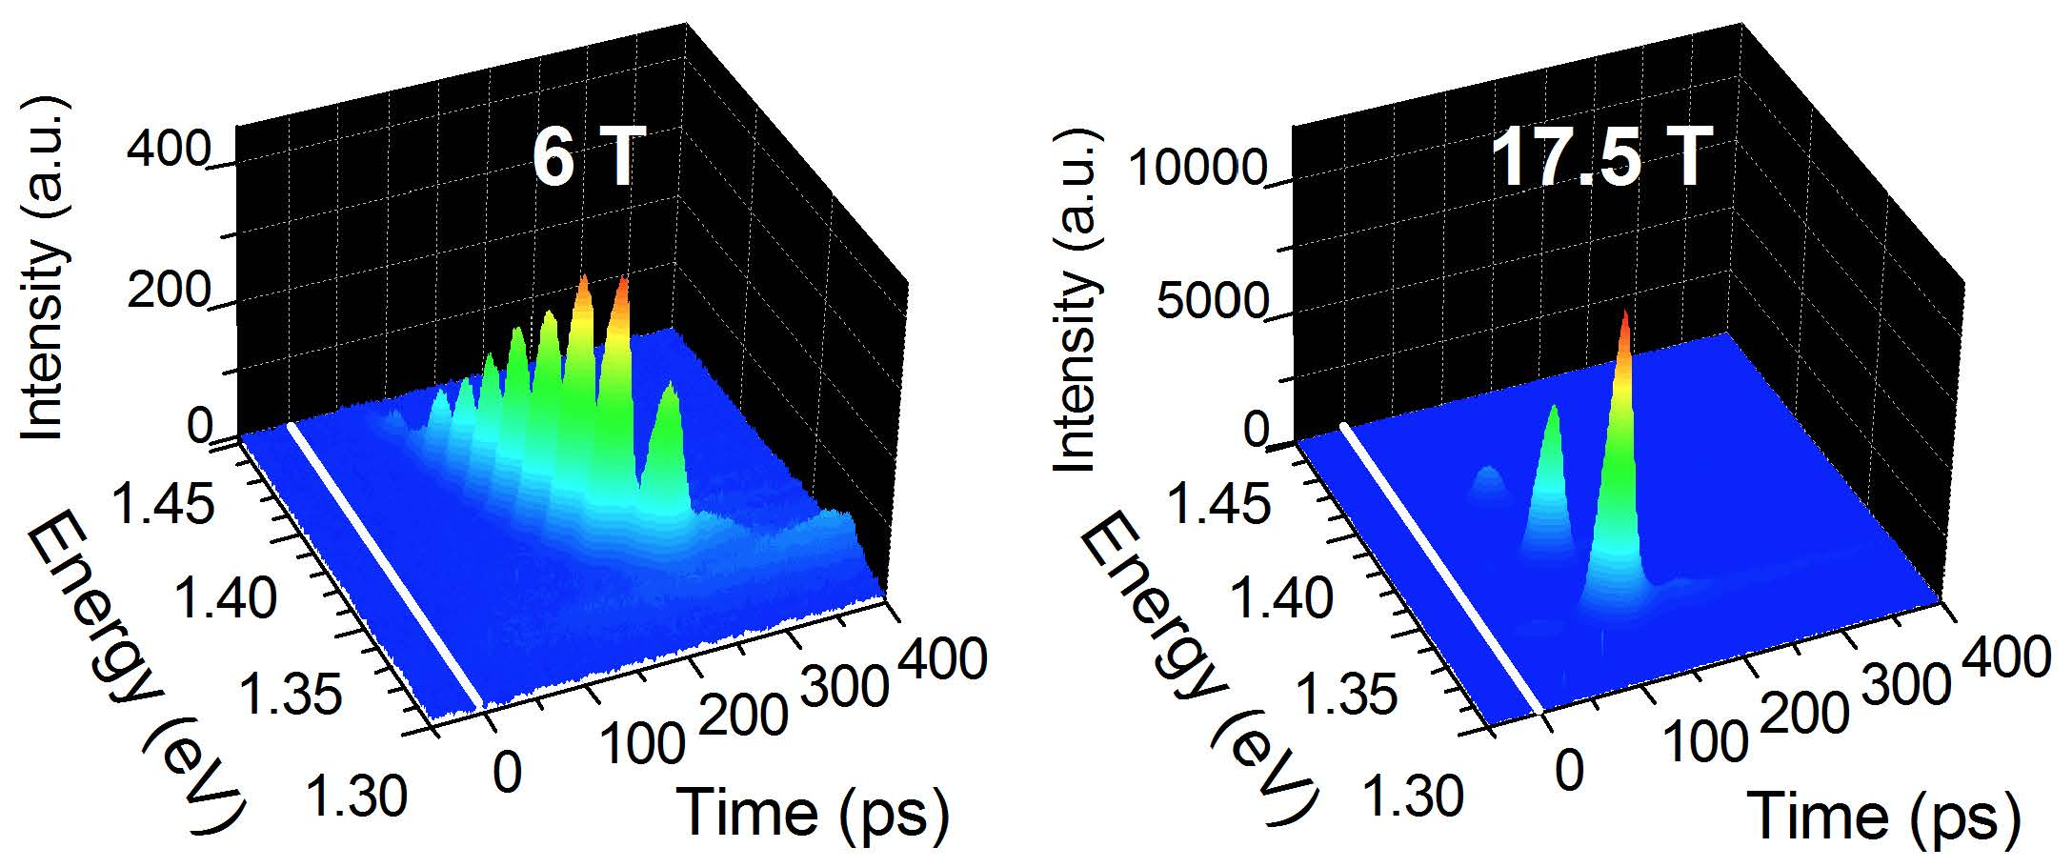
Fig. 1: Use Times New Roman (10) for figure caption.

The abstract submission format is the same for both oral presentation and poster presentation submissions. The deadline for abstract submission to be considered for an oral presentation is 11:59 pm, Monday, September 15, 2014 (in Central Daylight Time). After this deadline, all abstracts will be considered for poster presentations only. By September 30, you will be notified via email if you have been selected as an oral presenter. Submissions that are not selected for oral presentation will automatically be considered for poster presentation.

- J.-H. Kim, G. T. Noe II, S. A. McGill, Y. Wang, A. K. Wójcik, A. A. Belyanin, and J. Kono, “Fermi-Edge Superfluorescence from a Quantum-Degenerate Electron-Hole Gas,” Scientific Reports 3, 3283 (2013).
- L. Ren, C. L. Pint, T. Arikawa, K. Takeya, I. Kawayama, M. Tonouchi, R. H. Hauge, and J. Kono, “Broadband Terahertz Polarizers with Ideal Performance Based on Aligned Carbon Nanotube Stacks,” Nano Letters 12, 787 (2012).

